iTeam

Pupil Architecture Document

## Product Architecture

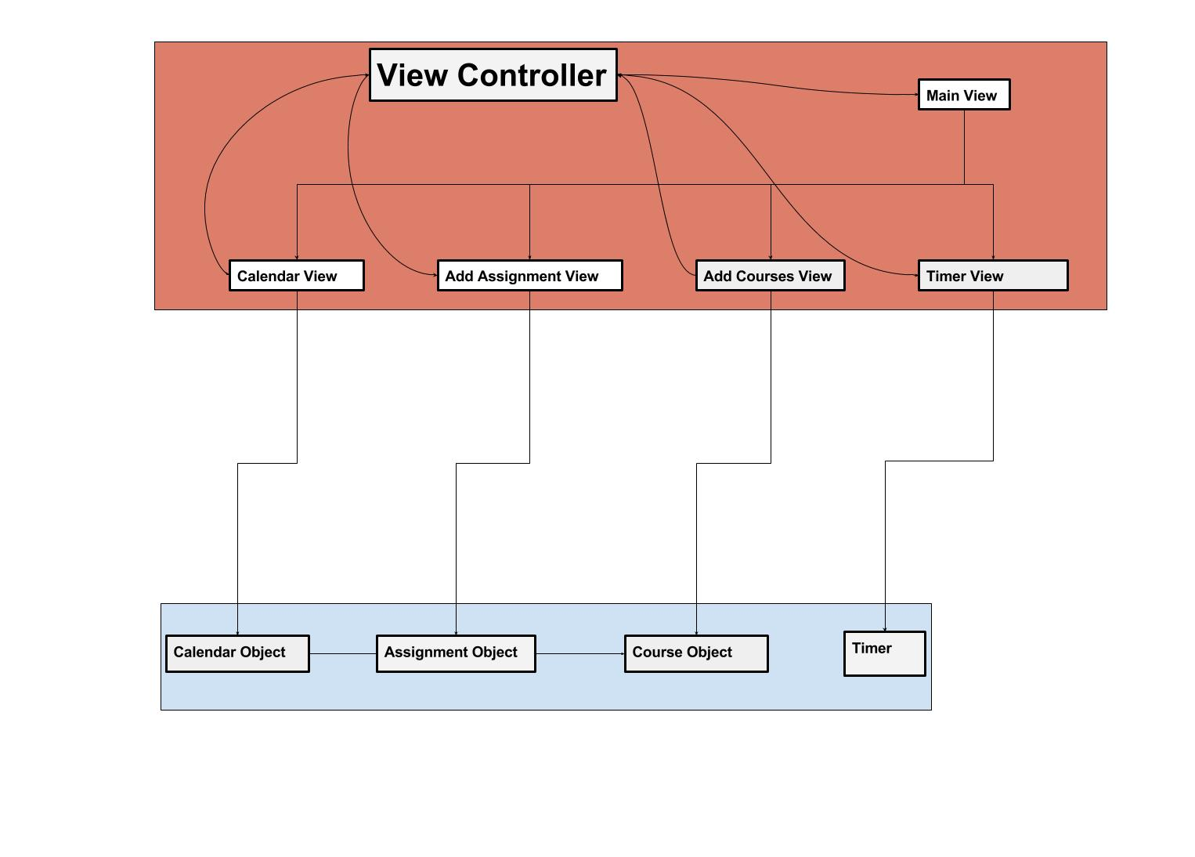

## System Boundaries

* Within pupil there are many systems that depend upon each other to function properly such as the calendar system which relies upon the assignment and reminder systems
* There is a grading and GPA system which rely on the data storage system of the user’s IOS device
* There is the IOS system and hardware systems of the iphone which rely on Pupil to safely function

Context Model

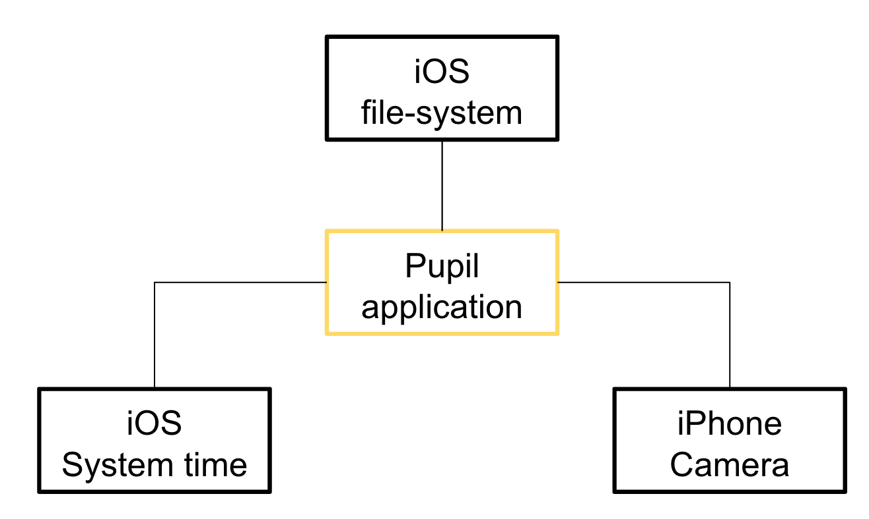

## Use Case 1

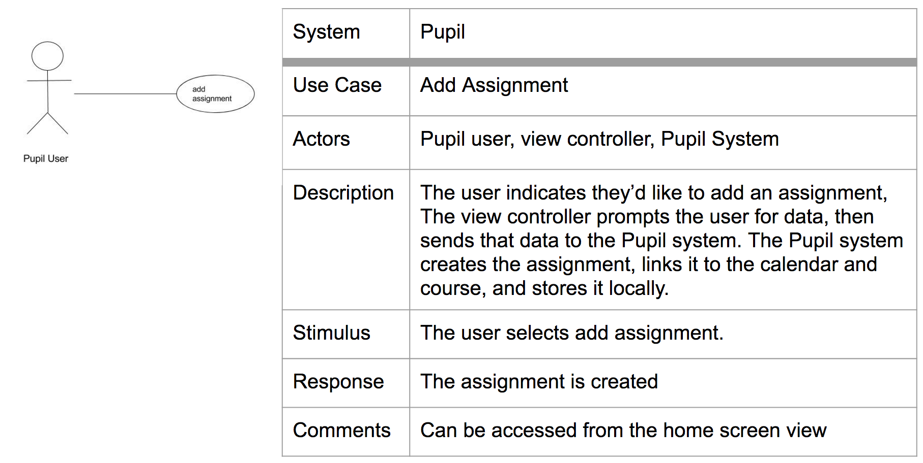

## Use Case 2

|  |  |
| --- | --- |
| System | Pupil |
| Use Case | Add Course |
| Actors | Pupil user, view controller, Pupil System |
| Description | The user indicates they’d like to add a course, The view controller prompts the user for data, then sends that data to the Pupil system. The Pupil system creates the course and stores it locally. |
| Stimulus | The user selects add course. |
| Response | The course is created |
| Comments | Can be accessed from home screen view |

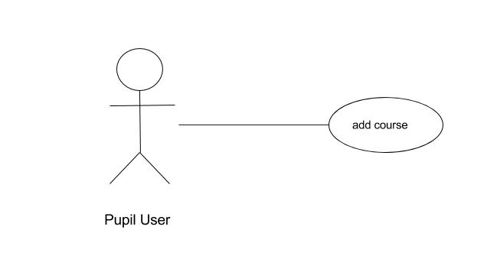

Use Case 3

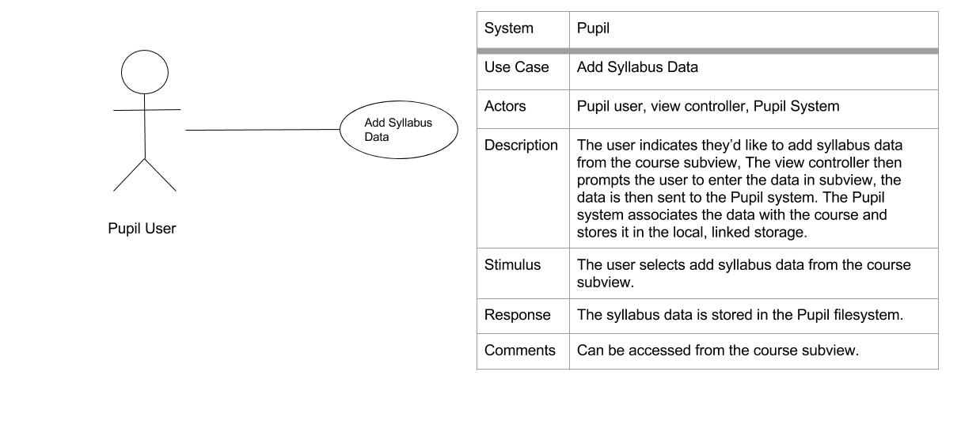

Use Case 4

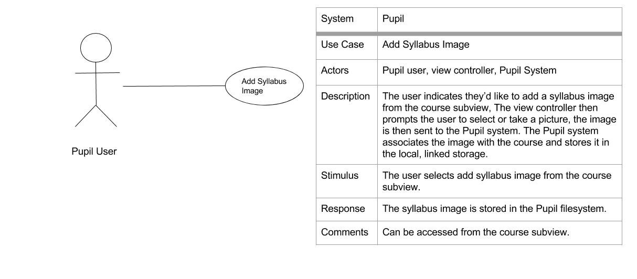

Use Case 5

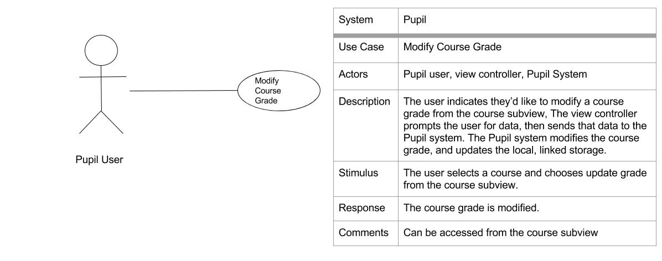

Use Case 6

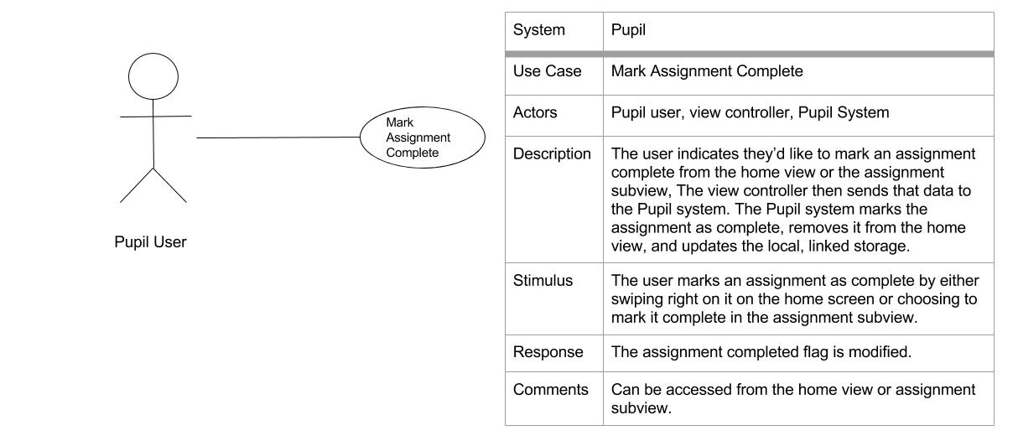

Use Case 7

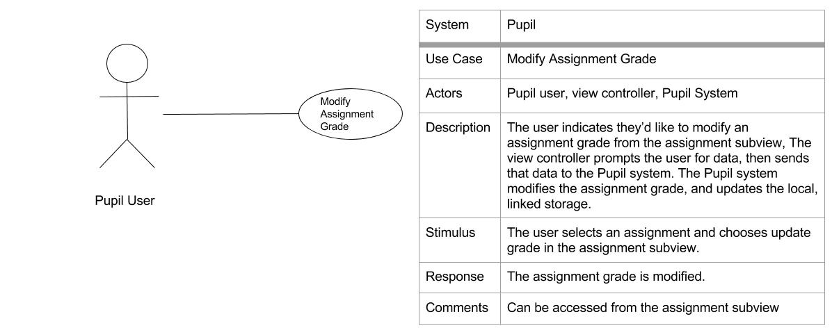

Use Case 8

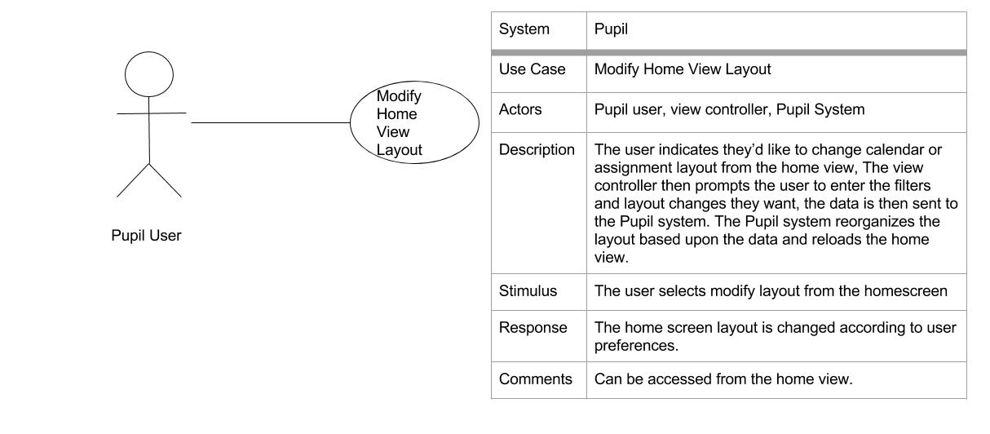

Activity Diagram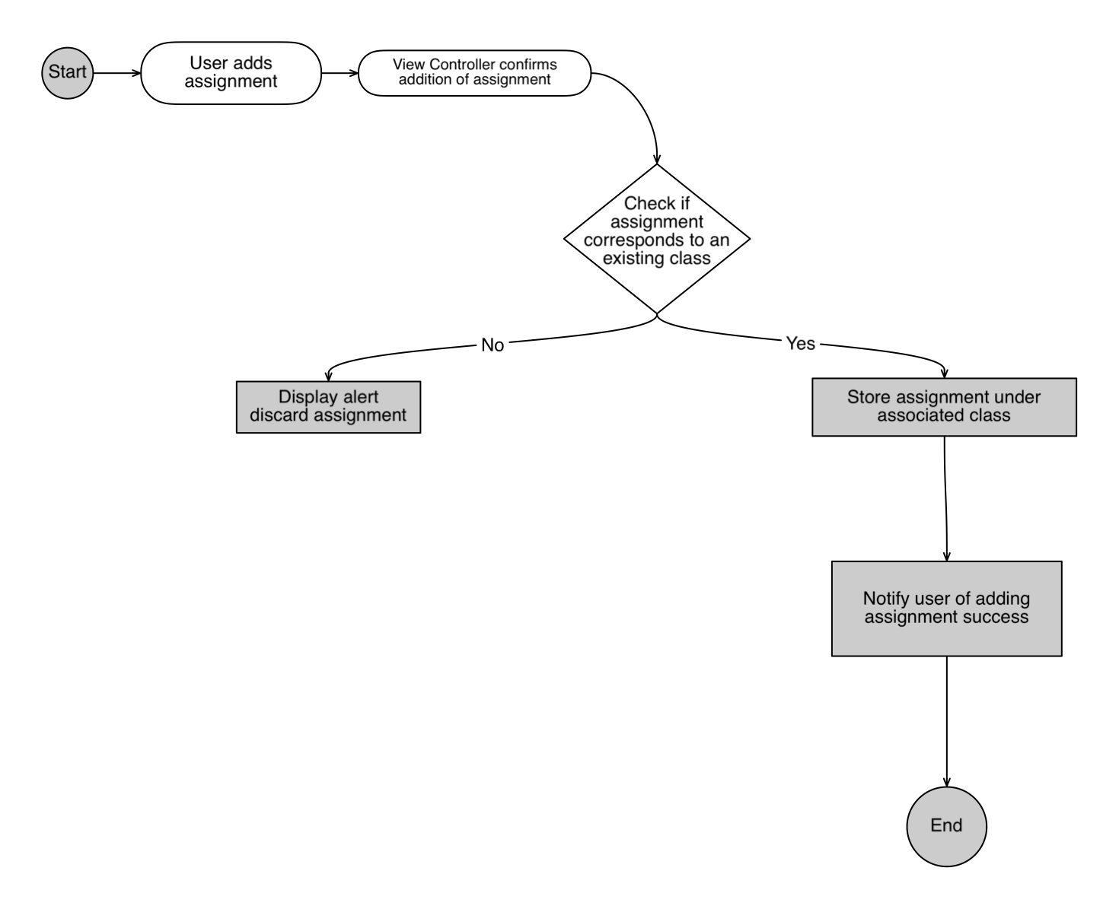

## Interaction with Sequence Diagram

Adding an Assignment:

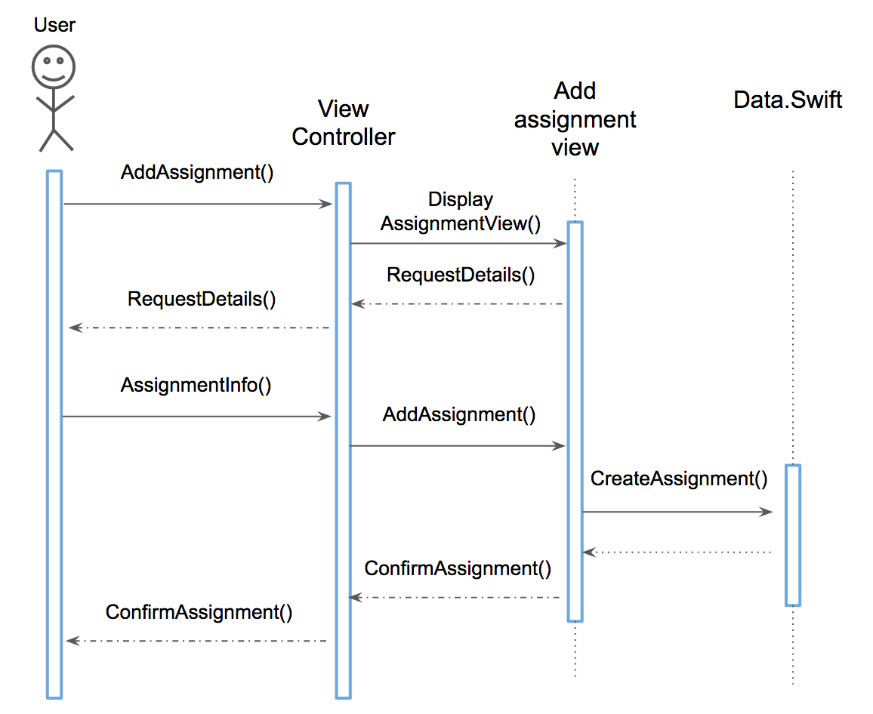

Adding a syllabus image

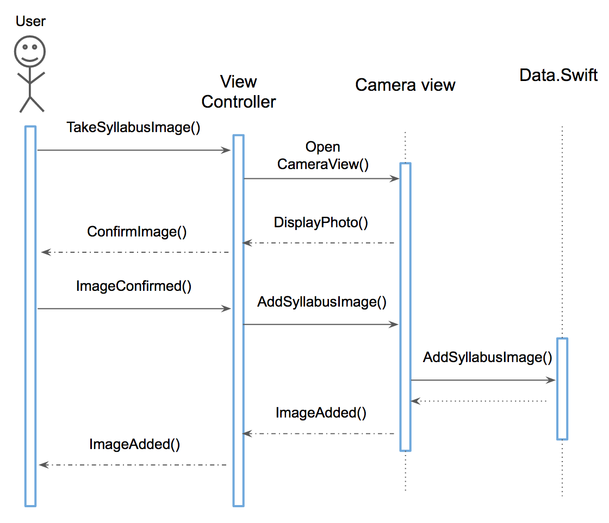

Using the Timer

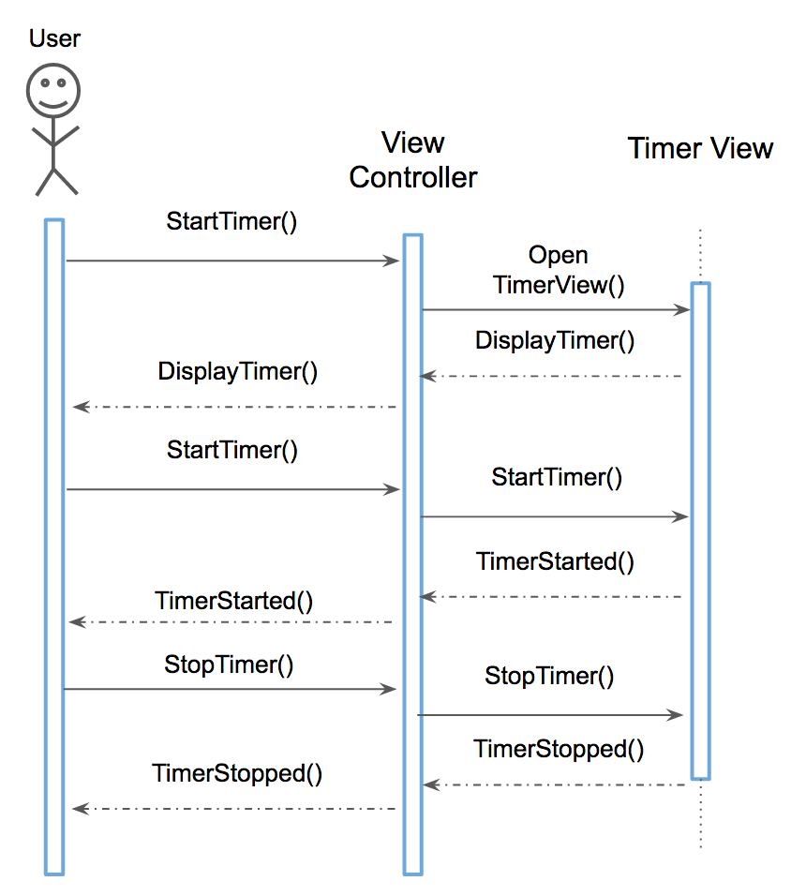

## Event Response State Diagram

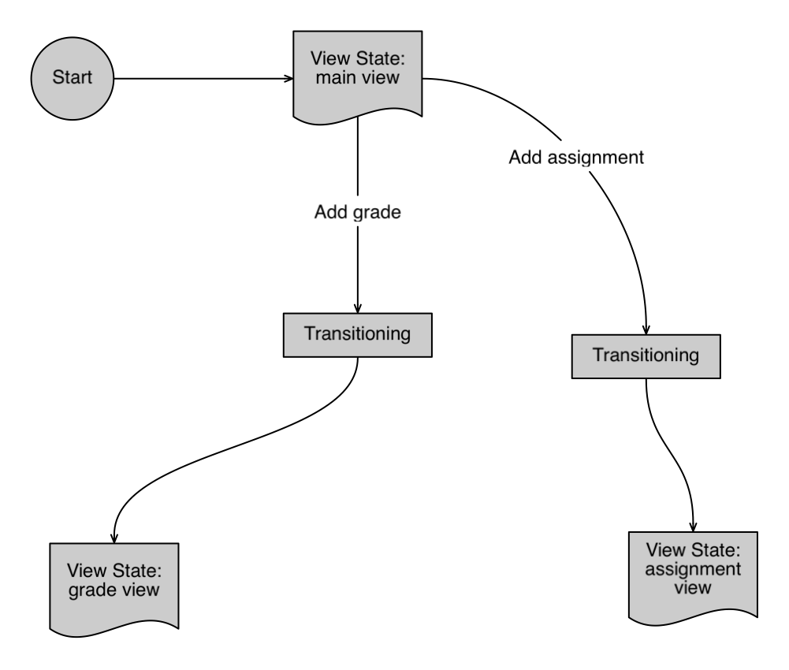

## Class Diagram

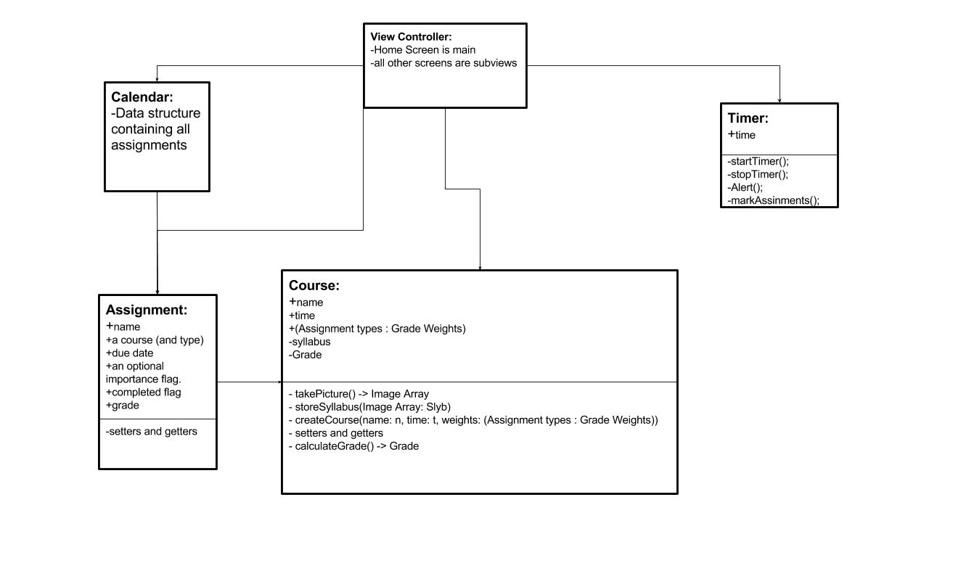

## Activity Diagram for Adding a Grade

